

CHILDREN’S
ATTENDANCE & TERM TIME LEAVE POLICY

2024

Ratified by Local Academy Committee Oct 2024

SECTION 1: POLICY

The law states that a child is required to attend regularly at the school where they are a registered pupil.

Regular school attendance and punctuality are extremely important. Valuable learning time is lost when children are absent or late. Children need to attend school regularly if they are to take full advantage of the educational opportunities available to them. The school’s ethos demonstrates that children feel that their presence in school is important, that they are missed when they are absent or late. The school will take appropriate action when necessary in order to promote the aims of the policy.

Aims:
- To maximise attendance of all children
- To provide an environment which encourages regular attendance and makes attendance and punctuality a priority for all those associated at the school
- To monitor and support children whose attendance is a cause for concern, and work in partnership with parents and carers to resolve any difficulties
- To analyse attendance data regularly to inform future policy and practice
- To work closely and make full use of the support from the wider community including the Local Authority Schools Attendance Support Officer and multi-agency teams

SECTION 2: ATTENDANCE GUIDANCE

Responsibilities of parents and carers:
By law parents and carers are responsible for ensuring children attend school regularly and punctuality rests with parents. However, where school attendance problems occur, the key to resolving these problems is engaging the child through collaborative working between the parent/carer, the school and the Local Authority.

Parents and carers should:
- Ensure their children attend school every day (unless they are sick)
- Ensure they are punctual for school
- Ensure they are appropriately dressed and in a condition to learn
- Comply with the attendance policy
- Make sure their child understands the reasons for good attendance and punctuality
- Make sure appointments are made outside of school hours wherever possible and show evidence of the appointment when it is not
- Notify the school on the first day (by 09:00) when their child is absent
- Not book holidays during term time
- Only allow absence from school for exceptional circumstances
- Work in partnership with the school

Responsibilities of the school

The school will:
- Have a registration system that is accurate, informative and consistent
- Analyse data regularly and identify the actions that need to be taken
- Follow up unexplained absences promptly
- Ensure that attendance and punctuality have a high profile in our communications with parents and carers
- Have clear written guidance for parents and carers
- Promote good attendance and punctuality for all
- Work in partnership with families
- Inform parents/carers of their child’s attendance regularly during the school year
- Set and monitor progress towards annual targets for attendance
- Evaluate the effectiveness of the Attendance Policy

The Local Authority Schools Attendance Support Service will work with the school to :
- Identify children/families with attendance difficulties
- Agree time limited action which needs to be taken by the school
- Feedback on the progress of cases and exchange of information
- Support the school to issue penalty notices where applicable
- Provide advice to the school
- Work in partnership with the school and families

SECTION 3: SCHOOL PROCEDURES
- The school uses SIMS to store and monitor its legal responsibilities in relationship to attendance. This system consists of specialised software.
- Registers are a vital legal document and teachers are required by their contractual duties to take an attendance register at the beginning of both the morning and afternoon sessions.
- Registers must be completed carefully and accurately, as they provide a record of a child’s attendance. Failure to complete a register accurately leaves the school vulnerable to complaint from parents or carers and constitutes a risk if an emergency evacuation has to take place.

Absence
Parents and carers can be prosecuted if they do not make sure their child attends school, without reason (as defined in law) and if the child has too many unauthorised absences.

Lateness
All parents and carers are responsible for their child’s travel arrangements to school and to ensure their child arrives on time.

School hours are as follows:
NB: your child will be recorded as late if they arrive 10 mins after their designated arrival time.
Year Groups | Arrival Time | End of School Day
EYFS and KS1 (Y1 and Y2) | 08:55 | 15:30
KS2 (Y3 to Y6) | 08:55 | 15:30

The school does not take responsibility for children on site prior to 8.45am unless they are attending the before or after school club or attending one of the school’s extra-curricular clubs. Children must not stay on site after their end of day, unless they are taking part in an organised school activity.
- Children must arrive at school on time (just before 08:45 when the gates are opened)
- All classroom doors will be shut at 08:55 Promptly.
- Children arriving after their arrival time must enter school through the School Office
- Children arriving 10 minutes after their designated arrival time will be registered as late
- Children arriving after 09:30 will be recorded as an un-authorised late unless a satisfactory reason is given, for example an urgent medical appointment
- Lateness is monitored by Mrs Kelly and Mrs Somes the School’s Attendance Team
- Action to address lateness will be taken in line with the school’s strategy to improve punctuality
- We expect parents and carers to collect their child promptly at the end of the school day as it is upsetting for children if they do not. Children who are not collected within 10 minutes of the end of the school day are brought to the school office and parents/carers contacted. Where children are persistently collected late from school, parents will be asked to meet with the school’s Attendance Officer (Mrs Kelly) or the Attendance Lead (Mrs Somes)

Illness
- Parents/carers are asked to contact the school before 9.00am each day that their child is absent, providing the reason for the absence, to give an update on how the child is and when the child is likely to return to school
- Where the school is not made aware of the reason for a child’s absence, they will contact parents/carers by telephone on the first day of absence
- If any member of staff is concerned about a reason for absence, the Headteacher/Senior Leadership Team will be informed
- In the event of continued sickness, parents and carers are advised to provide information from a relevant practitioner. This keeps pastoral and attendance staff informed of the child’s needs and appropriate support can then be arranged where necessary

(See Appendix 1 for School Absence Procedures).

Medical or Dental Appointments
Children must not leave the school premises during the school day without permission from the Headteacher, in consultation with the parents/carers. Routine medical or dental appointments should not be booked during school time. However, where appointments in school time are absolutely necessary, children should attend school for part of the day depending on the time of the appointment.

- Absence from school due to a medical or dental appointment will be considered as an authorised absence. Parents should inform the school in advance and show the letter or appointment card as evidence
- Parents/carers are encouraged to make all medical appointments out of school hours

Missing Physical Activities
Permission to be excused from PE or swimming should be made in writing to the teacher concerned and should only be for medical reasons. An explanatory note from a medical professional may be required should the class teacher see it as necessary to confirm and endorse the request. Please note that PE and swimming is part of the National Curriculum.

SECTION 4: LEAVE OF ABSENCE POLICY for SCHOOLS

Holidays During Term Time
The Education (Pupil Registration) Regulations 2006 have been amended and came into force from 1st September 2013. The amendments remove references to ‘holiday’ from school and extended leave of absence, as well as the statutory threshold of ten school days.

The Headteacher will not grant any leave of absence during term time unless there are exceptional circumstances for example a family funeral – evidence may be requested.

Requests for leave of absence will not be granted for the purposes of a holiday. The law does not give any entitlement to parents to take their child on holiday during term time. Headteachers have the discretion to authorise leave of absence in exceptional circumstances and it is only for the Headteacher to determine what is truly exceptional. School days are precious; children only attend school 190 out of 365 days.

Leave of absence will not be authorised in the following circumstances:
- Child’s attendance is less than 96% in the previous 12 months
- During SATs year (Year 6)
- At the beginning of any academic year
- Retrospectively – requests received after leave has been taken
- If there are any other academic concerns such as poor punctuality, child’s ability to catch up on the work missed etc.
- If leave of absence has already been taken in the same school year

We will also consider the following:
- The child’s general absence/attendance record, e.g. unauthorised absence
- Amount of time requested
- Age of the child
- Length of the proposed leave – no more than 5 days
- Child’s ability to catch up on the work
- Child’s educational needs
- General welfare of the child
- Circumstances of the request
- Purpose of the leave
- Frequency of the activity
- When the request was made

Applications for Leave of Absence
Requests must be made in advance or the absence cannot legally be authorised. All requests must be made at least two weeks in advance to the Headteacher, by completing the school’s application form – see Appendix 2. A parent/carer with whom the child resides must make the application. The form must be fully completed and you will receive a written response confirming if the request will be authorised or not.

If leave is granted (which will be extremely rare) and you are travelling abroad you will need to supply the school with confirmation of your return flight tickets, such as bringing a copy of the flight tickets into the school office for us to copy.

Unauthorised Absence
If you take your child out of school without the school’s prior authorisation (which is illegal), the absence will be recorded as unauthorised and noted in your child’s school records. Leave of absence can only be authorised by the Headteacher.

Where a parent/carer has taken their child on leave of absence during term time for 5 consecutive school days or more, without the Headteacher’s authorisation, Luton Local Education Authority may issue a Penalty Notice. In these circumstances a warning will not be given. Penalty Notices are per parent/carer, per child as appropriate, so if there are two parents/carers, both will need to pay the fine. From 1st September 2013 penalty notices will need to be paid within 21 days at £60 or £120 within 28 days. Unpaid Penalty Notices could result in prosecution for the absence in the magistrate’s court.

The school make the decision as to whether the request of leave should be granted or not and the Local Authority make the decision to impose a penalty for this.

Failure to return to school on the date expected
If there is a reason which delays the child in returning to school the parent/carer must inform the school immediately. The school will require evidence of this issue and will then decide whether the absence will be authorised. For any travel arrangements outside of the UK, we require proof of return flights, prior to the leave being taken. This may prevent you from receiving authorised absence for your child and being fined if they are unable to return on the date expected. Each case will be assessed individually and medical evidence from abroad will not be accepted routinely as evidence that a child was unable to attend school.

Roll Removal
A child can be removed from roll in either of these circumstances:

- If you take your child on a leave of absence which has been authorised by the school but your child fails to return on the agreed date, any extra time absent from school will be counted as unauthorised. If your child fails to return within ten days of the expected date of return, then the school may remove your child from the school roll and notify the Local Authority accordingly
- Or, if your child has 20 school days continuous unauthorised absence

If a child is removed from roll without information of a new school, the school will inform the Education Welfare Officer at the Local Authority and Child Missing in Education (CME) procedures followed.

Other Absence
Other absence from school will be considered on an individual basis and a decision will be made to authorise or unauthorise the absence.

SECTION 5: MONITORING AND REPORTING ATTENDANCE

Attendance is monitored regularly,

- The Attendance Officer will telephone families whose child is absent on the first day of absence where no phone call is received or no reason has previously been given
- Teachers must inform the Attendance Officer when they notice patterns of absence
- Attendance data will be reviewed weekly, to establish patterns of irregular attendance. This will include children with incomplete weeks; Monday and Friday absences; lateness; periods of extended absence; periods of un-authorised; and all children with attendance below 90%. This data will be discussed with the Local Authority Education Welfare Officer, as part of the regular half termly meetings
- The school and Local Authority Education Welfare Officer, will discuss the impact of the School’s Attendance Policy, attendance target and the strategies used to promote good attendance annually and the Headteacher will recommend an attendance target to the Governors
- Governors will receive attendance data and will hold the school accountable

Reporting Attendance

To Parents and Carers
All absences, both authorised and unauthorised, and lateness will be reported to parents and carers three times a year, during the Advent and Lent Parent/Carer Consultation Meetings and at the end of the academic year in their child’s annual report.

In order to give parents/carers a benchmark for their child’s attendance compared to other children in the school and nationally; the following grades will be used:

100% | Excellent
98% - 99.9% | Very Good
94% - 97.9% | Good
90% - 93.9% | Satisfactory
Under 90% | Unsatisfactory

Parents and carers are able to make an appointment with the Attendance Officer the Attendance Lead or Local Authority Education Welfare Officer, to discuss any concerns they have. (Appendix 3 – Attendance Factsheet)

Parents are given information about whole school attendance in weekly newsletters.

To Local Authority Education Welfare Support Service
The Attendance Officer provides an attendance print out of 95% and below to assist the Officer with their work.

To the Department for Education
Three times a year the school completes the Census return as per guidelines.

To the Governing Body
The Headteacher reports on attendance each term.

Promoting and Rewarding Good Attendance
Each week the class with the best attendance will receive a certificate.

Improving Poor Attendance
The regular monitoring and analysis of school registers, enables patterns and trends to be identified. See Appendix 4 for school monitoring procedures.

Children who are subject to either a Child Protection or Child In Need Plan (CIN), children who are in public care (CLA), Young Carers and any other vulnerable child’s attendance are prioritised each day for absence phone calls and reporting. This is the responsibility of the Admin Officer who will report directly to the Attendance Lead/SLT with any concerns.

96% and below
If attendance drops below 96% the Attendance Officer will inform parents/carers with a letter (Appendix 5) advising them that their child’s attendance/punctuality will be monitored for the next four weeks. Parents are able to meet the Class Teacher, Attendance Officer or a member of the SLT to discuss this further.

90% and below
If attendance drops below 89% the child is classed as a ‘Persistent Absentee’. Parents will be invited to a meeting with the Attendance Lead and in some cases a member of the SLT. This meeting will be followed up with a letter (see Appendix 6).

85% and below
If attendance is below 85%, the child continues to be classed as a ‘Persistent Absentee’, at this stage the Local Authority Schools Attendance Officer, may meet with parents/carers. Fixed penalties may be incurred with the possibility of prosecution where no significant improvement is evident.

The aim throughout this process is to ensure all children have the best attendance possible. The school will work in partnership with parents/carers and take into account individual circumstances, applying the process accordingly.

A visit to families at home will be conducted, at any time, where necessary.

Improving Punctuality

Step 1
Once a child has arrived late for school on two occasions within a week a letter will be sent home with the expectation that punctuality will improve (see Appendix 7).

Step 2
If the child continues to be late in the following week the Attendance Lead or a representative from the school, will make a phone call to parents/carers to inform them of the number of lates their child has incurred and to find out reasons for the poor punctuality.

Step 3
If the child persists in being late the Attendance Officer will arrange a meeting with the child and parent/carer where actions and targets will be set (see Appendix 8).

Policy Implementation
The policy and associated guidance will be discussed with staff and governors.
A copy of registration guidance will be given to supply staff working in the school.
Families will be informed of the attendance procedures via the school website, school induction meetings and newsletters.

The policy will be reviewed in September 2024, or sooner if regulations change.

The term parent includes those who have parental responsibility as defined in the Children Act 1989 and as defined in Section 576 of the Education Act 1996. The later gives parental responsibility to those who may not be the child’s actual parents but have day to day care of the child.

Appendix 1

ABSENCE PROCEDURES

DAILY FROM DAY 1
Telephone call or parentmail message from parent to explain absence before 9.00am.
School to telephone parent by 10am to establish reason for absence.
NO NO

YES
Reason obtained
YES
Absence recorded with appropriate code.

NO
SLT to make decision made whether a home visit is conducted based on prior knowledge and current attendance.
If no response a note is left requesting parent to contact school. The school may also request a Police Welfare Check.
If child is subject to a CP plan or LAC contact allocated Social Worker and discuss school actions.

Attendance Policy followed.
Child discussed at next Case Review Meeting with SLT where actions are identified.


Appendix 2
Sacred Heart Catholic Primary School
Langford Drive, Luton
Beds. LU2 9AJ
Tel: 01582 287480

CHILD LEAVE of ABSENCE REQUEST FORM
Please complete a form for each child you are requesting absence for. You will receive a copy of this form once your request has been considered for authorisation and a copy will be placed in your child’s file.

Date of Submitting Absence Request: | Name of Child: |  | Child’s Class:
Date of Absence Requested: | From: |  | To (please note this is the date we expect your child to return to school):
Reason for Absence Request: (please note that the Headteacher will not authorise any holidays in term time)

Parent/Carer 1 Name and Signature: |  | Parent/Carer 2 Name and Signature:
If there are two Parents/Carers in the family, both need to sign this form.
Please be informed that the school is not permitted to authorise any absence during term time for a holiday.

It is a legal requirement that registered pupils of compulsory school age (5+) attend school regularly and punctually and parents or guardians risk prosecution if they fail in this duty. Amendments to the 2007 Regulations in the Education (Penalty Notices) (England) (Amendment) Regulations 2013 came into force on 1 September 2013.

A fixed penalty notice will be issued when a child has a minimum of 10 school sessions recorded as unauthorised in a 6-week period in term time; (a school day is two sessions - morning and afternoon) or when a child has a series of unauthorised absences leading to irregular attendance.

A copy of the school's attendance policy is available on the website or upon request if you require further information.

School Use Only | Date request for absence received (Date Stamp): |  |  |  | Child’s Attendance:
Unauthorised |  | Authorised |  | Part Authorised | If Part Authorised How Many Sessions?
Signature: |  |  | Print Name: |  | Date:
School Stamp:
Copies: SENDCo/ Family Worker / Pupil File / Office / Parents


Appendix 3
Sacred Heart Primary School
Attendance Information

Remember – Always apply to Mrs Somes via the leave of absence request form if you need to request leave during term time.

By law, all children must receive a full time education. As a parent/carer you are responsible for making sure that your child attends school regularly and on time.

What can I do to help my child attend school regularly?

- Ensure your child attends school every day and on time
-If your child is ill, contact the school on the first day of absence by parentmail or phone call (01582 287450)
-Take an interest in your child’s education
-Only take holidays in school holiday time
-Talk to the school if you have concerns

Regular attendance also means
PUNCTUAL attendance.

Arrive on time for your child’s designated start time

Year Groups | Arrival Time | End of School Day
EYFS and KS1 (Y1 and Y2) | 08:55 | 15:30
KS2 (Y3 to Y6) | 08:55 | 15:30

All children arriving 10 minutes after their designated start time will receive a late mark (L code on the register)

Children arriving after 09:30am receive a “U” code on the register – unauthorised late absence

Please remember to pick your child/children up on time.

Illness

-Children must not attend school if they have any infectious illnesses (please take advice from your GP) e.g. Chicken Pox, Measles, German Measles, mumps etc.
-Sickness and Diarrhoea (48 hours)
-Flu (diagnosed by GP) etc.

The school will always contact you if your child is unwell – always try to send your child to school even if they feel a little “under the weather” e.g. runny nose, tummy ache, headache etc.

If you are unsure if your child can attend school, please contact the school office for further information and advice 01582 287450

Unacceptable reasons for absence:

- Shopping
- Birthday treats and trips
- Looking after others at home
- Non-urgent medical or dental appointment
- Your car breaking down
- Picking up or taking relatives to the airport
- Family Holidays etc.
These absences will be marked as unauthorised

Appendix 4

Sacred Heart Catholic Primary School’s
Attendance Monitoring Procedures

At Sacred Heart, we strongly believe that outstanding attendance is vital to ensuring that every child achieves their potential. Therefore, we strive to improve constantly and achieve an attendance of 96% or above.

100-96% | •Constant monitoring of attendance by Attendance Lead  •Certificates issued termly to celebrate 96%+ attendance  •Weekly rewards for classes with the highest attendance
Step 1  95-93% | •Constant monitoring of attendance by Attendance Lead  •Regular monitoring by Education Welfare Officer  •Child encouraged to improve attendance by Class Teacher/Key Stage Leader  •Telephone home from class teacher to notify parents/carers that attendance has dropped below 96% followed up with letter 1  •Support offered to parents through meeting with Attendance Lead, family Worker, SENDCo, Class Teacher etc.
Step 2  92%-90% | •Daily monitoring of attendance by school  •Parents/carers invited to meet with Attendance Welfare Officer  •Parents/carers invited to meet with Attendance Lead, Key Stage Lead, Family Worker SENDCo etc. followed up with letter 2 and Attendance Action Plan with support from Family Worker, this may include a request for medical evidence to be provided in order for absences to be authorised  •Home visit from school if appropriate
Step 3  89-85%  Persistent Absentee | •Daily monitoring of attendance by school and Education Welfare Officer  •Parents/carers invited to meet with Attendance Lead and SLT, followed up with letter 3 and Attendance Action Plan  •Home visit from school if appropriate
Step 3  84% & below  Persistent Absentee | • Education Welfare Officer will monitor attendance  •Fixed penaltiesand fast track to prosecution for those parents/carers that do not demonstrate significant improvement actioned by the Education Welfare Officer.

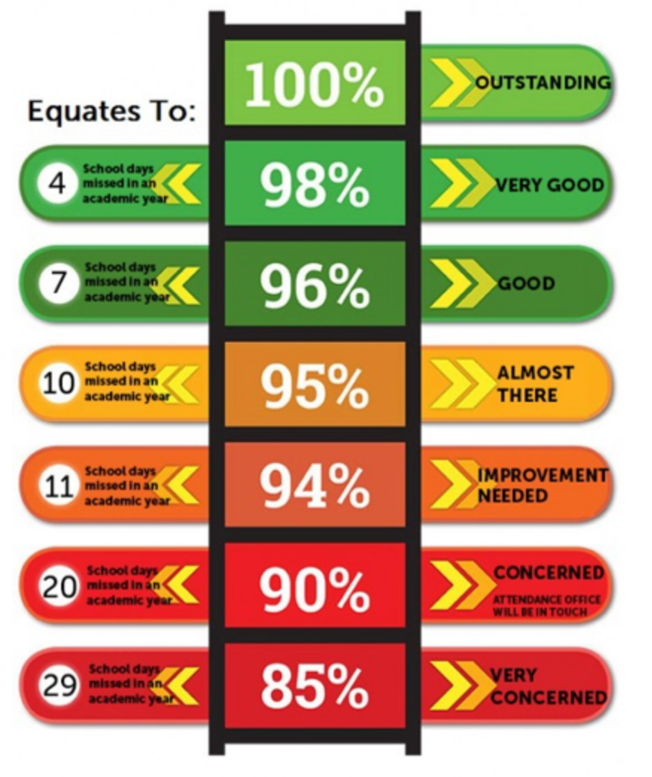

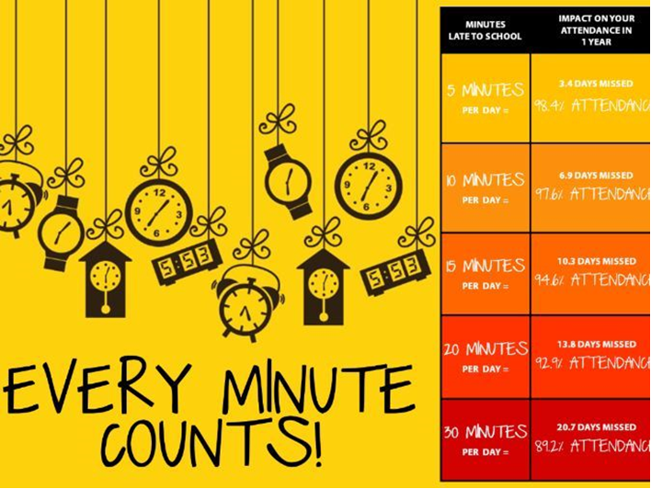

Appendix 8 (Letter 6)


Sacred Heart Primary School

Headteacher: Mrs G Somes
Langford Drive, Luton, Beds. LU2 9AJ
Tel: 01582 287480
E-Mail admin@sacredheart.primaryluton.co.uk

Dear Parent/Carer of {Pupil Name}

We have noticed that {Pupil Name} is often absent for register in the mornings.

We know that mornings can be difficult for some pupils, and we are keen to help to improve {Pupil Name}’s attendance.

As I am sure you are aware, regular attendance at school is crucial for children to make good academic and social progress. It is essential to promote good habits from an early age and for children to recognise the importance of being on time and attending school regularly.

Children that are late to school:
- often feel self-conscious – having to enter the classroom alone
- miss the beginning of the lesson, which contains the introduction for the work from the teacher
- have to catch up with the rest of the lesson
- miss the social part of the beginning of the day
- cause disruption to all other class members

We would love to talk to you to discuss avenues for support to help {Pupil Name} attend school well. Please contact [insert staff member name and contact information] to make an appointment or arrange a phone call.

Kind regards
Terrie Kelly
Attendance Officer

Sacred Heart Primary School

Headteacher: Mrs G Somes
Langford Drive, Luton, Beds. LU2 9AJ
Tel: 01582 287480
E-Mail admin@sacredheart.primaryluton.co.uk

Dear Parent/Carer of {Pupil Name}

We need your help, please.
{Pupil Name} has been absent for {#} days of school, which is equal to {#} lessons missed so far this school year.

We know that sometimes our pupils cannot come to school because they are really unwell - and that's the right thing to do for them and other students. Medical advice is clear however that children with mild illness will often be well enough to attend - for example if they have a cough, or cold, without a temperature. The NHS guidance Is my child too ill for school? - NHS (www.nhs.uk) is designed to support parents in their decision making about mild illness.

We also know that pupils fall behind their friends and classmates when they miss school. At Sacred Heart Primary school, we want the amount of missed education to be reduced as much as possible. We believe that our community is stronger together, with all of our pupils in school, on time, every day. We are building life skills, life-long friendships and preparing your child for future success.

We also know that you can have a significant effect on {Pupil Name} absences this academic year and we would really appreciate your help and support ensuring that {Pupil Name} comes to school every day so that they can get the best possible outcomes. We want to work with you to achieve this – please call or come in and meet {Pupil Name}’s class teacher or tutor if there is anything we can do to support you or your child. We appreciate that every family’s situation is unique.
We will be in touch again to request a meeting with you if we have ongoing concerns about your child’s attendance.

Kind regards

Terrie Kelly
Attendance Office

Sacred Heart Primary School

Headteacher: Mrs G Somes
Langford Drive, Luton, Beds. LU2 9AJ
Tel: 01582 287480
E-Mail admin@sacredheart.primaryluton.co.uk

Re: First attendance warning letter
Dear [parent/carer’s name],
I am writing to you because [pupil’s name]’s attendance has become a cause for concern. It currently stands at [add percent].
Regular attendance is an important factor in a child’s academic success. When pupils are frequently absent, it is difficult for them to keep up with their school work and this could affect their life chances. For this reason, we take school attendance very seriously.
If your child is going to be absent from school, it is important that you contact the school on the first day of the absence to inform us of the reasons. If this continues for more than one day, you should make contact with the school on a daily basis to keep us updated.
We are keen to work with you to address any barriers to your child’s attendance. If you require any advice or support on this matter, please get in touch with [add name and contact details] to discuss this and we will do our best to help.
Yours sincerely,

Terrie Kelly

Attendance Officer

Sacred Heart Primary School

Headteacher: Mrs G Somes
Langford Drive, Luton, Beds. LU2 9AJ
Tel: 01582 287480
E-Mail admin@sacredheart.primaryluton.co.uk

Re: Second attendance warning letter
Dear [parent/carer’s name],
Following our previous letter dated [date of first letter] regarding [child’s name]’s attendance, there continues to be a cause for concern. Our records show that [insert name of child]’s attendance is currently at [add percent].
School attendance is an important issue and something we take very seriously. I am therefore requesting that you come into school to discuss the current situation.
I have arranged for this meeting to take place in school on [add date] at [add time]. Please could you confirm that you are able to attend this meeting. If you are unable to attend, please contact the school office to make an alternative arrangement.
Regular school attendance is the responsibility of parents/carers. If your child’s attendance remains at the current level, a referral will be made to the local authority who may need to start legal proceedings.
We look forward to your support in resolving this matter.
Yours sincerely,

Terrie Kelly
Attendance Officer

Sacred Heart Primary School

Headteacher: Mrs G Somes
Langford Drive, Luton, Beds. LU2 9AJ
Tel: 01582 287480
E-Mail admin@sacredheart.primaryluton.co.uk

Re: Final attendance warning letter
Dear [parent/carer’s name],
Following two previous letters, we are now writing to formally express our ongoing concerns about the irregular attendance of your child, [add name and date of birth].
If a pupil fails to attend school regularly, the parent could be guilty of an offence under section 444 of the Education Act 1996. I am therefore warning you that, if further unauthorised absences are recorded, or your child fails to attend school regularly, we will need to refer this matter to the local authority.
Following this notification, if your child’s attendance and/or punctuality does not improve, the local authority may start legal proceedings against you.
If issued with a fine, or penalty notice, each parent must pay £80 within 21 days or £160 within 28 days. The payment must be made directly to the local authority.
If it is determined that an offence has been committed, this could eventually result in a fine of up to £2,500, a community order or imprisonment.
We will not issue further notification should we need to escalate this matter to the local authority.
We have attached a record of your child’s attendance with this letter.
Yours sincerely,
Terrie Kelly
Attendance Officer

Appendix 8 (Letter 6)


Sacred Heart Primary School
Interim Headteacher: Mrs G. Somes
Langford Drive,
Luton,
Beds. LU2 9AJ
Tel: 01582 287480
e-mail admin@sacredheart.primaryluton.co.uk

Date:

Dear Parents/Carers,

We would like to congratulate you and NAME, for making the improvements necessary to meet the attendance target of 96% or above.

NAME’s attendance has now reached xxx%

We have been really impressed by your hard work and hope that we will continue to see the impact of this in the future.

Well done to you all ☺.

Yours sincerely

Mrs Kelly
Attendance Officer

