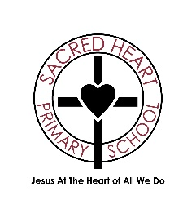

**Sacred Heart Catholic Primary School**

**Behaviour Statement 2024**

At Sacred Heart Catholic Primary School, we recognise that Jesus is our greatest teacher. Following Jesus’ example, we strive for our school to be a place where everyone is equally respected and unconditionally loved.

At Sacred Heart we understand that the Gospel Virtues underpin all we do and we ensure they are intrinsically linked to our Behaviour Policy.

We strive to enable all members of our school community to thrive in an environment where all feel listened to, considered, valued, loved and respected, this is lived through our mission statement:

**‘Jesus at the Heart of All We do.’**

* Staff and volunteers aim to be strong role models for children. Through their actions they show children how to treat each other
* We aim to know and treat all children and staff as individuals and provide support at all times. We are fully committed to safeguarding and the welfare of all children
* We expect respect, good manners and a drive to be the best versions of ourselves
* Rewards, consequences and reasonable force are used consistently by staff, in line with the behaviour policy
* The Behaviour Policy is shared with and understood by children their families and all staff
* The Suspension and Permanent Exclusions Policy explains that suspensions and exclusions will only be used as a last resort, and outlines the processes involved in permanent exclusions and suspensions
* The Local Academy Committee also emphasises that violence or threatening behaviour in school will not be tolerated under any circumstances

*This written statement of behaviour principles is reviewed and approved by the LAC each academic year or as needed.*