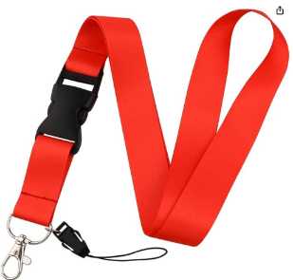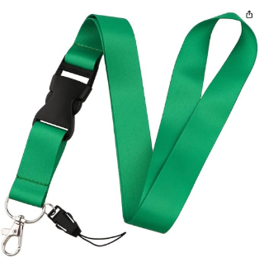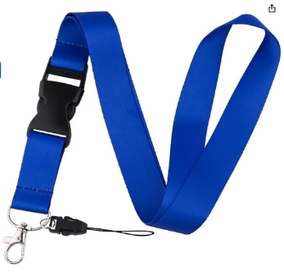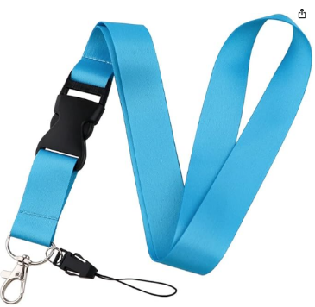

Visitor

Visitor

Staff

Safeguarding Team

A visitor who can move around school by themselves.

Sacred Heart staff.

If you are worried about feeling sad, upset or alone please speak to a member of staff with this lanyard.

Visitor who needs to be with a member of staff with a dark blue or light blue lanyard.

If you see a person without a lanyard or a person who has a red lanyard who is on their own, tell another adult straight away!

Lanyards at Sacred Heart Primary