

**Asthma Policy**

**November 2023**

**Rationale**

At Sacred Heart Catholic Primary School we adhere to the following principles:

* We welcome all pupils, including those who may suffer from asthma recognising that asthma is a condition affecting many school children
* We will encourage and help children with asthma to participate fully in all aspects of school life
* We will be sensitive to the feelings of some asthma sufferers, who feel awkward about their condition and about taking medication
* We recognise that immediate access to reliever inhalers is vital
* We will do all we can to make sure that the school environment is favourable to children with asthma
* We will ensure that other children understand asthma so that they can support their friends, and so that sufferers can avoid the stigma sometimes attached to this condition
* We encourage all staff, but especially our trained First Aiders, to have a clear understanding of what to do in the event of a child having an asthma attack
* We aim to work in partnership with parents, governors, health professionals, school staff and children to ensure the successful implementation of this Policy
* We will keep a register of all children with asthma, added to our main allergy register, which is accessible to all school staff and supply staff, and which is updated regularly
* We will ensure there is regular training for staff, parents and children delivered by the Community Asthma Nurse

**What is asthma?**

We understand asthma to be a condition which causes the airways in the lungs to narrow, making it difficult to breathe. Sudden narrowing produces an attack.

Asthma sufferers have almost continuously inflamed airways and are therefore particularly sensitive to a variety of triggers or irritants. These include:

* viral infections ( especially colds )
* allergies ( e.g. grass pollen, furry or feathery animals )
* exercise
* cold weather, strong winds or sudden changes in temperature
* excitement or prolonged laughing
* fumes e.g. from glue, paint, tobacco smoke

We are aware that psychological stress may sometimes make symptoms worse.

**How are children affected?**

We are aware that children with asthma may have episodes of breathlessness and coughing during which wheezing or whistling noises can be heard coming from the chest. They feel a "tightness" inside their chest which can be frightening and may cause them great difficulty in breathing.

We understand that different children have different levels of asthma and therefore may react differently.

**Precautions to help the prevention of asthma attacks in school**

We believe in the principle of "prevention rather than cure ". So, in school we…

* have white boards instead of blackboards to avoid the use of chalk
* operate a no-smoking policy
* think carefully before allowing furry pets into classrooms
* have warm-up sessions at the beginning of PE and Games lessons
* are aware of the dangers of glues, spirit pens etc. and of the need for correct use and ventilation
* as far as possible we try to be an aerosol free school

**Treatment for asthma in school**

All children with diagnosed asthma will have an ‘Individual Asthma Plan’ this is written by the parents and the Community Asthma Nurse which is kept in the class medical files.

We understand that treatment takes two forms: relievers and preventers - the former taken when needed and the latter regularly as a prevention. We are aware also, that relievers need to be taken promptly and so where possible children will keep their inhalers on them or with their teacher or in the classroom first aid cupboard.

To ensure speedy and correct action we…

* ensure that children who are able to take their medication independently are encouraged to carry their inhalers with them at all times
* will store inhalers and spacers, labelled with the child`s name, in an accessible place in the classroom
* administer or supervise self-administration of medication with spacers
* ensure that medication is taken on school trips

We also undertake to inform parents/carers if we believe a child is having problems taking their medication correctly.

We will also discuss with parents/carers if we feel that there are signs of poorly controlled asthma.

**Parent/Carer responsibilities**

We believe in a partnership with parents and carers. We ask them…

* to inform us if a child suffers from or develops asthma
* to ensure that the child is provided with appropriate medication, to notify us of this medication and the appropriate action for its use
* to notify us of any change in medication or condition
* to make us aware of any known triggers or allergies
* to inform us if sleepless nights have occurred because of asthma
* to take inhalers/spacers/nebulisers home regularly for cleaning and checking
* to replace inhalers before they expire/run out
* we expect parents of children who need to use an inhaler regularly in school to obtain a second one from their doctor so that one may be left at school

In order to capture all this information parents complete an Asthma Information form – see Appendix 1, in addition either a Individual Care Plan or a Wheeze Plan – Appendix 2.

**Procedure in the event of an asthma attack in school**

We expect that older children will be aware of what to do in the event of a threatened attack. However, we adhere to the following guidelines with all children:

* send immediately for a First Aider
* we will endeavour to remove the child from the source of the problem, if known
* alert SLT by phone
* ensure that the child`s reliever medicine is taken promptly and a second dose taken if necessary
* stay calm, reassure the child and listen carefully to what the child is saying
* help the child by encouraging slow breathing
* encourage others around to carry on with their normal activities
* encourage the child to sit upright and lean slightly forward over the back of a chair - hands on knees sometimes helps; we do not allow the child to lie down
* loosen tight clothing, offer a drink of water and open windows or doors to give a supply of fresh air

We will call an ambulance if:

* the reliever has no effect after five minutes;
* the child is either distressed, unable to talk or very pale
* the child is getting exhausted
* the child’s condition is deteriorating
* we are in any way concerned about medical condition of the child
* we would consult the asthma plan and share this with the ambulance crew

At this point we will also notify the parent or carer, or contact the emergency number if the parent or carer is unavailable. Doses of the reliever will be repeated as needed while awaiting help, being aware of the possibility of overdosing and following the instructions from the emergency services.

**Asthma and Sport in school**

Full participation in all sport for all asthma sufferers is our aim, unless the child is a very severe sufferer and we are notified as such by the parents/carers.

We bear the following in mind when planning sports lessons, with asthma sufferers in mind:

* 15 minutes prior to the lesson if a child has exercise induced asthma, they take a dose of medication before exercise
* inhalers need to be speedily available when the child is out of the school building so all teachers will have an inhaler box to collect them in and to be placed at the location of the activity
* any child complaining of being too wheezy to continue in sport, will be allowed to take reliever medication, a First Aider will be notified to attend in order that their condition can be monitored
* we aim to ensure a warm-up period before full exercise
* we realise that long spells of exercise are more likely to induce asthma than short bursts and that exercise with arms or legs alone is less likely to trigger an attack than exercise using both

**Some implications of implementing our Policy**

We are aware that, if medication is to be readily available in classrooms, there is always the possibility of another child, perhaps a non-sufferer, taking a dose. Since the medication simply dilates the airways, we understand this would not be harmful, although we would discourage the practice.

We would also discourage one child from using another child`s inhaler, for reasons of hygiene and possible unsuitability. However, in an emergency, we regard it as more appropriate to use another child`s inhaler, rather than none, despite the disadvantages.

We also have an asthma emergency kit available in school for emergencies located in the Admin Office and in the KS1 Medical Room.

Parents’ permission is always sought prior to administering the inhaler and this can be seen on the child’s individual Asthma Plan.

** Sacred Heart Catholic Primary School**

Appendix 1

**Asthma Information**

|  |  |
| --- | --- |
| Name of child |  |
| Date of birth |  |
| Class |  |
| **Inhaler** |  |
| Name & colour of inhaler |  |
| Is inhaler in school? |  |
| When does your child need their inhaler?  What are the triggers? |  |
| Dosage |  |
| Can your child use their inhaler independently? |  |
| **If for any reason your child’s inhaler is not available we hold an emergency Salbutomol inhaler in school. Please give your permission for this to be used.**  Signature:………………………………………………  **Contact Details** | |
| Name |  |
| Daytime telephone no. |  |
| Relationship to child |  |

The above information is, to the best of my knowledge, accurate at the time of writing and I give consent to school staff administering medicine in accordance with the school policy. I will inform the school immediately, in writing, if there are any changes in dosage or frequency of the medication or if the medicine is stopped.

Signature:…………………………………… Relationship to child:……………………………

Date:…………………………

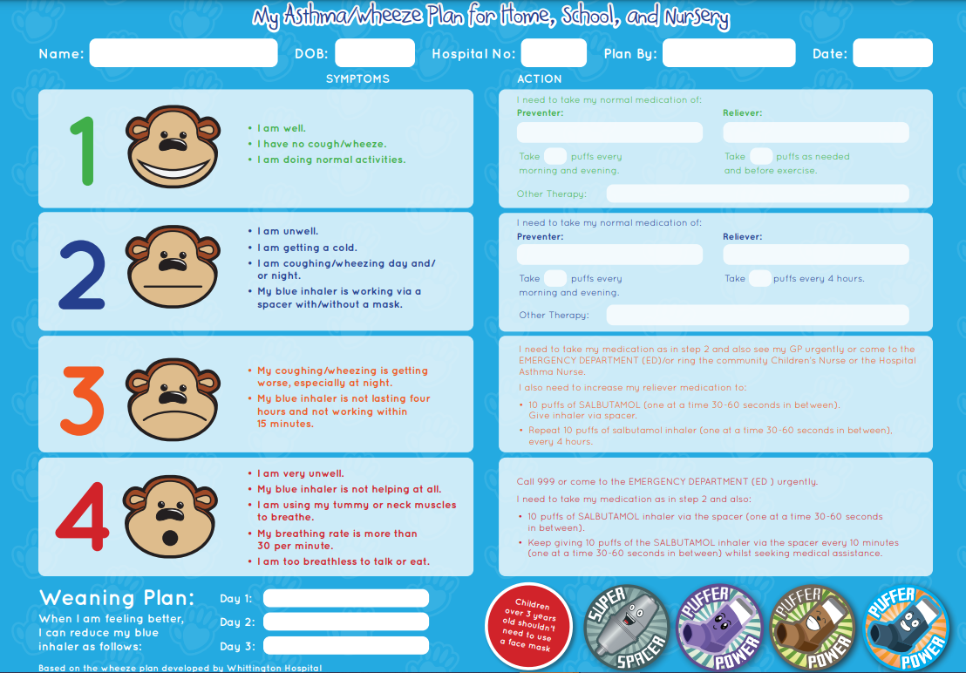Appendix 2

